Ananda Bagaskara Poetra Dwiki

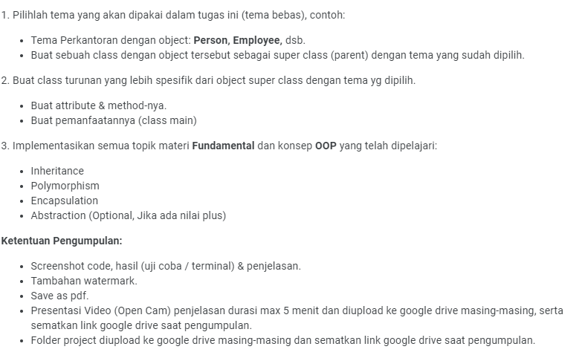

**Jawab:**

Source Code:

Tema yang saya pakai adalah sekolahan dengan object: teacher dan students. Students sebagai super class (parent) dan teacher sebagai Derived atau Child Class.

saya membuat class student dengan attribute ID, Name, Age, Address, Phone.

Saya menggunakan **encapsulation** dengan jenis Public

using System;

namespace SchoolDays

{

public class Student

{//Encapsulation

public string ID; //attribute

public string Name;

Saya menggunakan **Inheritance**, ‘menurunkan’ property dan method yang dimiliki parent class kepada child class. public class Teacher : Student

public int Age;

public string Address;

public int Phone;

public virtual void DataOffical() //Polymorphism Overriding

{

Console.WriteLine("============");//menampilkan output

Console.WriteLine("ID : " + ID);

Console.WriteLine("Name : " + Name);

Console.WriteLine("Age : " + Age);

Saya menggunakan **Polymorphism Overriding**, pada method parent class: public virtual void DataOffical() dan pada method Child Class: public override void DataOffical().

Console.WriteLine("Address : " + Address);

Console.WriteLine("Phone : " + Phone);

}

}

public class Teacher : Student //Inheritance

{

public string TeachExp; //teaching experience

public string LastEdu; //LastEducational

public override void DataOffical() //Polymorphism Overriding, Derived atau Child Class

{

base.DataOffical(); //untuk memunculkan data yang terdapat diparent

Console.WriteLine("Teaching Experience : " + TeachExp);

Console.WriteLine("Last Educational : " + LastEdu);

}

}

class Program

{

static void Main(string[] args)

{

Student student1 = new Student(); //object students

student1.ID = "340013";

student1.Name = "Kung Lao";

student1.Age = 20;

student1.Address = "9870 Chinatown";

Disini saya juga membuat object student dan juga teacher. Dan saya juga dapat memberikan value terhadap atribut yg telah ada.

student1.Phone = 22312;

student1.DataOffical();

Teacher teacher1 = new Teacher(); //object teacher

teacher1.TeachExp = "11 Years";

teacher1.LastEdu = "Associate Degree";

teacher1.ID = "922135";

teacher1.Name = "Raiden";

teacher1.Age = 43;

teacher1.Address = "1445 Chinatown";

teacher1.Phone = 33821;

teacher1.DataOffical();

}

}

}

Output Keseluruhan:

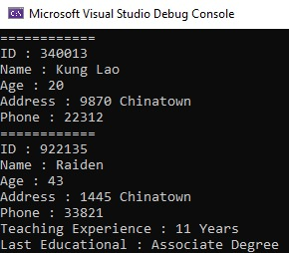

[*https://drive.google.com/file/d/1Bmcx3c49AkmlR2W-uHdDVvZw8kxZnu8r/view?usp=share_link*](https://drive.google.com/file/d/1Bmcx3c49AkmlR2W-uHdDVvZw8kxZnu8r/view?usp=share_link)